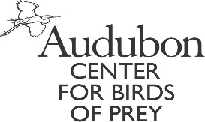

Raptor Camp 2018

GENERAL INFORMATION

Child’s Name:
 |  |  | Last |  |  |  |  |  |  |  |  |  |  |  | First |  |  |  |  |  |  |  |  | M.I.
Birth Date |  |  |  |  | Wt: |  |  |  | Ht. |  |  |  |  | Male |  |  |  |  |  | Female
 |  | mm/dd/yy
Parent or Guardian:
Home Address:
Home Phone: |  |  |  |  |  |  |  |  |  | Business Phone:
Family Physician: |  |  |  |  |  |  |  |  |  |  |  |  |  |  |  | Phone:
Address:
Family Dentist or Orthodontist: |  |  |  |  |  |  |  |  |  |  |  |  |  |  |  | Phone:
Address:

In an emergency, please contact:
1. Name: |  |  |  |  |  | 2. Name:
Address: |  |  |  |  |  | Address:
Phone: |  |  |  |  |  | Phone:

Do you carry medical/hospital insurance? |  |  | If yes, indicate carrier:
Policy or Group #: |  |  |  | Phone:

The following people are permitted to drop my child off or pick my child up:
Please note that identification will be checked during pick-up.
1. Name: |  |  |  |  |  | Relation:
2. Name: |  |  |  |  |  | Relation:
3. Name: |  |  |  |  |  | Relation:
4. Name: |  |  |  |  |  | Relation:

We want your child to have the best week possible at Raptor Camp. Is there anything you’d like for us to know about your child, their behavior or tendencies? (Continue on back of page if needed)

MEDICAL AUTHORIZATION
I hereby give my permission for non-prescription medication to be given to my child if deemed advisable by Audubon. The following non-prescription medication should not be given to my child:
I hereby give permission to the medical personnel selected by Audubon to order x-rays, routine tests, treatment; to release any records necessary for insurance purposes; and to provide or arrange necessary related transportation for me or my child. In the event I cannot be reached in an emergency, I hereby give my permission to the physician selected by Audubon to secure and administer treatment, including hospitalization, for the person named above. I agree that I will be solely responsible for paying any costs associated with medical treatment. This completed form may be photocopied for trips.
Any directions to the contrary should be specified below and signed.
Parent’s/Guardian’s signature: |  |  | Date:

RELEASE OF LIABILITY AND USE OF IMAGE

As the child’s parent and/or legal guardian, I understand that my child will be participating in Audubon’s __________________________________________________________________________________ (the “Program”), which will include classroom and outdoor field trip experiences. I understand there are possible dangers associated with the Program, including but not limited to, ________________________________________________________
______________________________________________________________________________________________. I understand that my child’s participation in the Program may involve sustained physical activity. My child is in good health and I am aware of no physical problem or condition that will limit or interfere with my child’s ability to participate in the Program.

I agree that my child is participating in the activity at my own risk, and acknowledge that Audubon has made no warranty or representation, expressed or implied, regarding the safety of conducting the Program.

I hereby grant permission to Audubon to reproduce my child’s appearance, name, likeness, voice and biographical information in connection with the Program in any and all manners, including promotional materials, and any and all media, including the Internet, throughout the world and in perpetuity.

I expressly release Audubon, its officers, directors, employees, agents, licensees, successors and assigns from and for any and all claims, demands or causes of action which I have or may have for (i) libel, defamation, invasion of privacy or right of publicity arising from Audubon’s use of my child’s appearance, name, likeness, voice and biographical information, including but not limited to, the distribution, broadcast or exhibition thereof or (ii) on account of any loss, damage, or injury to person or property suffered or incurred by my child, except by Audubon’s negligence, in connection with any aspect of my child’s participation in the Program or in any Program-related activity, including any transportation arranged by, paid for or provided by Audubon.

This release shall be binding upon me and my heirs, next of kin, executors, administrators and assigns. By signing below, I acknowledge that I have thoroughly read and understand this form and that the statements I have made are all true.

(CALIFORNIA RESIDENTS:) I expressly waive all rights under Section 1542 of the Civil Code of California, which reads as follows: A general release does not extend to claims which the creditor does not know or suspect to exist in his favor at the time of executing the release, which if known by him must have materially affected his settlement with the debtor.

Parent’s/Guardian’s signature:___________________________________ Date:______________

MEDICAL HISTORY

IMPORTANT: Parents/Guardians, please notify Audubon if this child is exposed to any communicable diseases during the three weeks prior to your child’s Audubon participation. If you feel you do not have enough current information to fill out this form accurately, please contact your physician.

IMMUNIZATION (Record year of last immunization only or disease).
Diptheria/Tetanus |  | Measles |  | Chicken Pox |  | Polio
Rubella |  | Mumps |  | TB (and result) |  | Other

SPECIAL INFORMATION
 |  |  |  | Yes |  | No
Contact Lenses
Sleepwalking
Bedwetting
Frequent ear infections
Seizure disorder
Heart defect/disease
Diabetes
Bleeding clotting disorder
Recent exposure to contagious diseases
Allergic reactions (plant, insect, food, medicine) |  |  |  |  |  |  |  | Type:
Other
Are there any activities to be restricted?
If yes, explain:
Operations or serious injuries (specify dates):
Chronic or recurring illness:
Special diet or restrictions (vegetarian, etc.):

MEDICATIONS BEING TAKEN:
Please list all medications (including non-prescription drugs) taken routinely at home. Bring enough medication to last the entire stay at Audubon. Keep it in the original packaging/bottle that identifies the prescribing physician, the name of the drug, dosage and frequency of administration. All medications (with the exception of inhalers) will be in the possession of Audubon.
 |  | This camper takes NO medication on a routine basis.
 |  | This camper takes medications as follows:
Medication: |  |  |  |  | Dosage: |  | Times taken each day:
Reason for taking:
Medication: |  |  |  |  | Dosage: |  | Times taken each day:
Reason for taking:

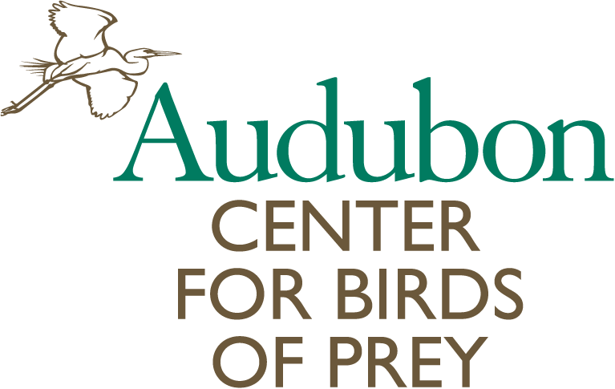
Raptor Camp Behavior Agreement

Hey Camper, Raptor Camp at the Audubon Center for Birds of Prey is a fun-filled experience! You’ll learn new things, be involved in exciting activities, crafts and games as well as meet new friends. To ensure that you have awesome time, please read with your parent/guardian and then sign below (have your parent/guardian sign too!)

At all times:
* Respect your fellow campers and camp teachers.
* Listen to your camp teachers, staff and other campers when they are talking.
* Stay with your group.
* Keep your hands and feet to yourself.
* Never throw objects at each other or into any animal enclosures.
* Walk! Always walk in the Center, there will be time to run at the Park when we play games.
* Talk in a quiet voice. No shouting or screaming. This could scare the birds.

Discipline Policy
Violations to camp rules will be handled in the following manner:
Minor Rule Violations (examples, but not limited to, include talking while a teacher is talking, running, disrupting program, throwing objects, etc.)
* First offense - Verbal warning
* Second offense - Verbal warning and exclusion from a camp activity
* Third offense - Exclusion from a camp activity and parent notification at the end of the day (written or in person).

Major Rule Violations (examples, but not limited to, include aggressive actions taken from one camper toward another camper, counselor or animal. Disregard of the rules such as wandering from the group, pushing, shoving, hitting, verbal abuse, cursing, bullying, etc.)
* First offense — Camper conference and telephone call to parent. Parent may be asked to pick camper up immediately and/or camper may be asked not to return to camp. No refund will be given if dismissed.
* Second offense — Camper will be dismissed from camp. Parent will be contacted to pick camper up immediately. No refund will be given.

Signing below indicates that I have read, understand, and agree to follow these rules.

__________________________________ __________________________________
Camper Signature Parent/Guardian Signature

__________________________________ __________________________________ Print Camper Name Print Parent/Guardian Name

